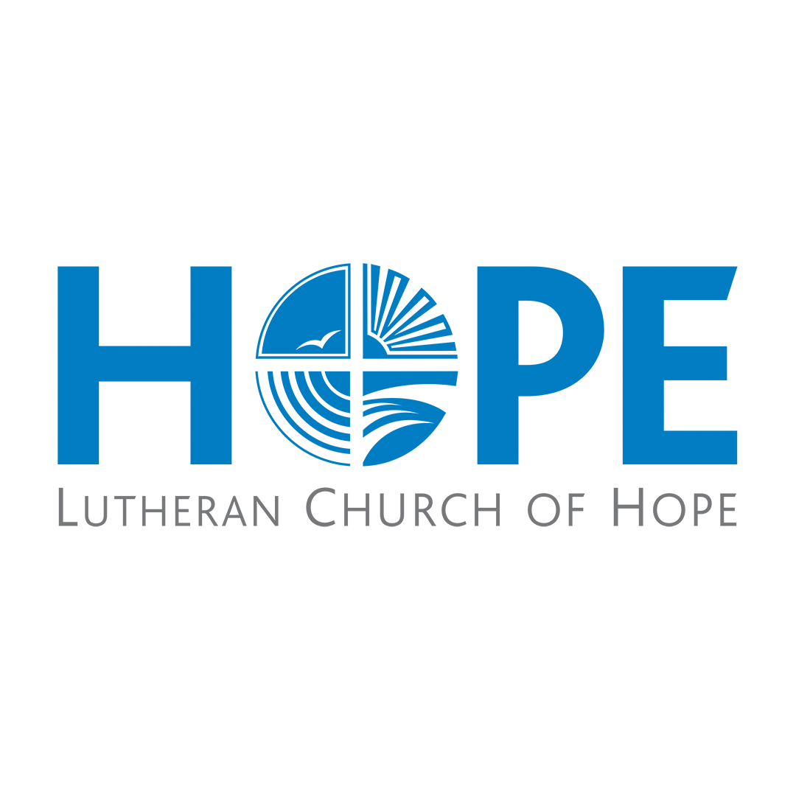

Position Description

Position Title: Title Goes Here
Reports To: Title Goes Here
Date Prepared/Revised: August 4, 2020

Principle Function

The Hospitality Coordinator is responsible for carrying out the operational vision for Lutheran Church of Hope (a congregation under the mission, vision, values, and authority structure of Lutheran Church of Hope), under the direction of the campus pastor and in cooperation with the satellite team leaders.

Primary Functions

- Working to provide a Christ-centered, professional, and hospitable experience for all guests and members at weekend services, weekday events, and any classes through:
- Oversight of weekend service operations, volunteer coordination, special service needs or supplies.
- On-site presence for four services per month (spread over three weekends) as well as large church events as needed.
- Oversight of new member class set-up, materials, hosts, clean up, and follow up.
- Assistance with funeral or wedding hospitality as needed.

- Providing weekly coordination of volunteer team members for all weekend worship operational positions including, but no limited to ushers, greeters, scripture readers, communion team, coffee service, welcome center, parking team, security team, and prayer partners. This includes:
- Timely and professional scheduling and communication
- Regular training and updates
- Actively seeking to build volunteer teams through building relationships, offering care, connection, and interest in member’s lives.

Secondary Functions

With the support of the Campus Pastor and Leadership Team, the Hospitality Coordinator will also:

- Meet regularly with the operations director for debrief, feedback, leadership development and planning.
- Attend weekly Hope Des Moines staff meetings.
- Have a consistent presence at Lutheran Church of Hope Des Moines church-wide events (i.e. Christmas, Easter, Vacation Bible School, large missions events) when necessary or as assigned.

- Support the mission, vision, values, and authority structure of Lutheran Church of Hope and the vision for multi-site ministry.
Personal Responsibilities

- Adhere to Lutheran Church of Hope Staff Covenant for spiritual, personal and professional relationships and behavior.
- Maintain a vital and growing personal walk with the Lord through committed Bible study, prayer and personal learning.

Skills, Education and Experience Required
- Possess Christ-centered, joy-filled passion for ministry which flows from a vibrant personal relationship with Jesus Christ
- Extremely strong organizational skills for administration and leadership of team-based ministry
- Ability to supervise, inspire, and equip volunteers.
- Ability to prioritize and boundary ministry with personal and family life
- Ability to lead, coordinate and manage multiple tasks
- Extremely people oriented, with a contagious spirit for service
- Commitment to always reflect in the best possible light Lutheran Church of Hope, its staff, and the mission, vision, and values of its Constitution, the Southeast Iowa Synod, and the Evangelical Lutheran Church of America.

Position Details

Hours: 10 hrs/wk

Pay and Benefits: Per agreed upon Compensation Package

